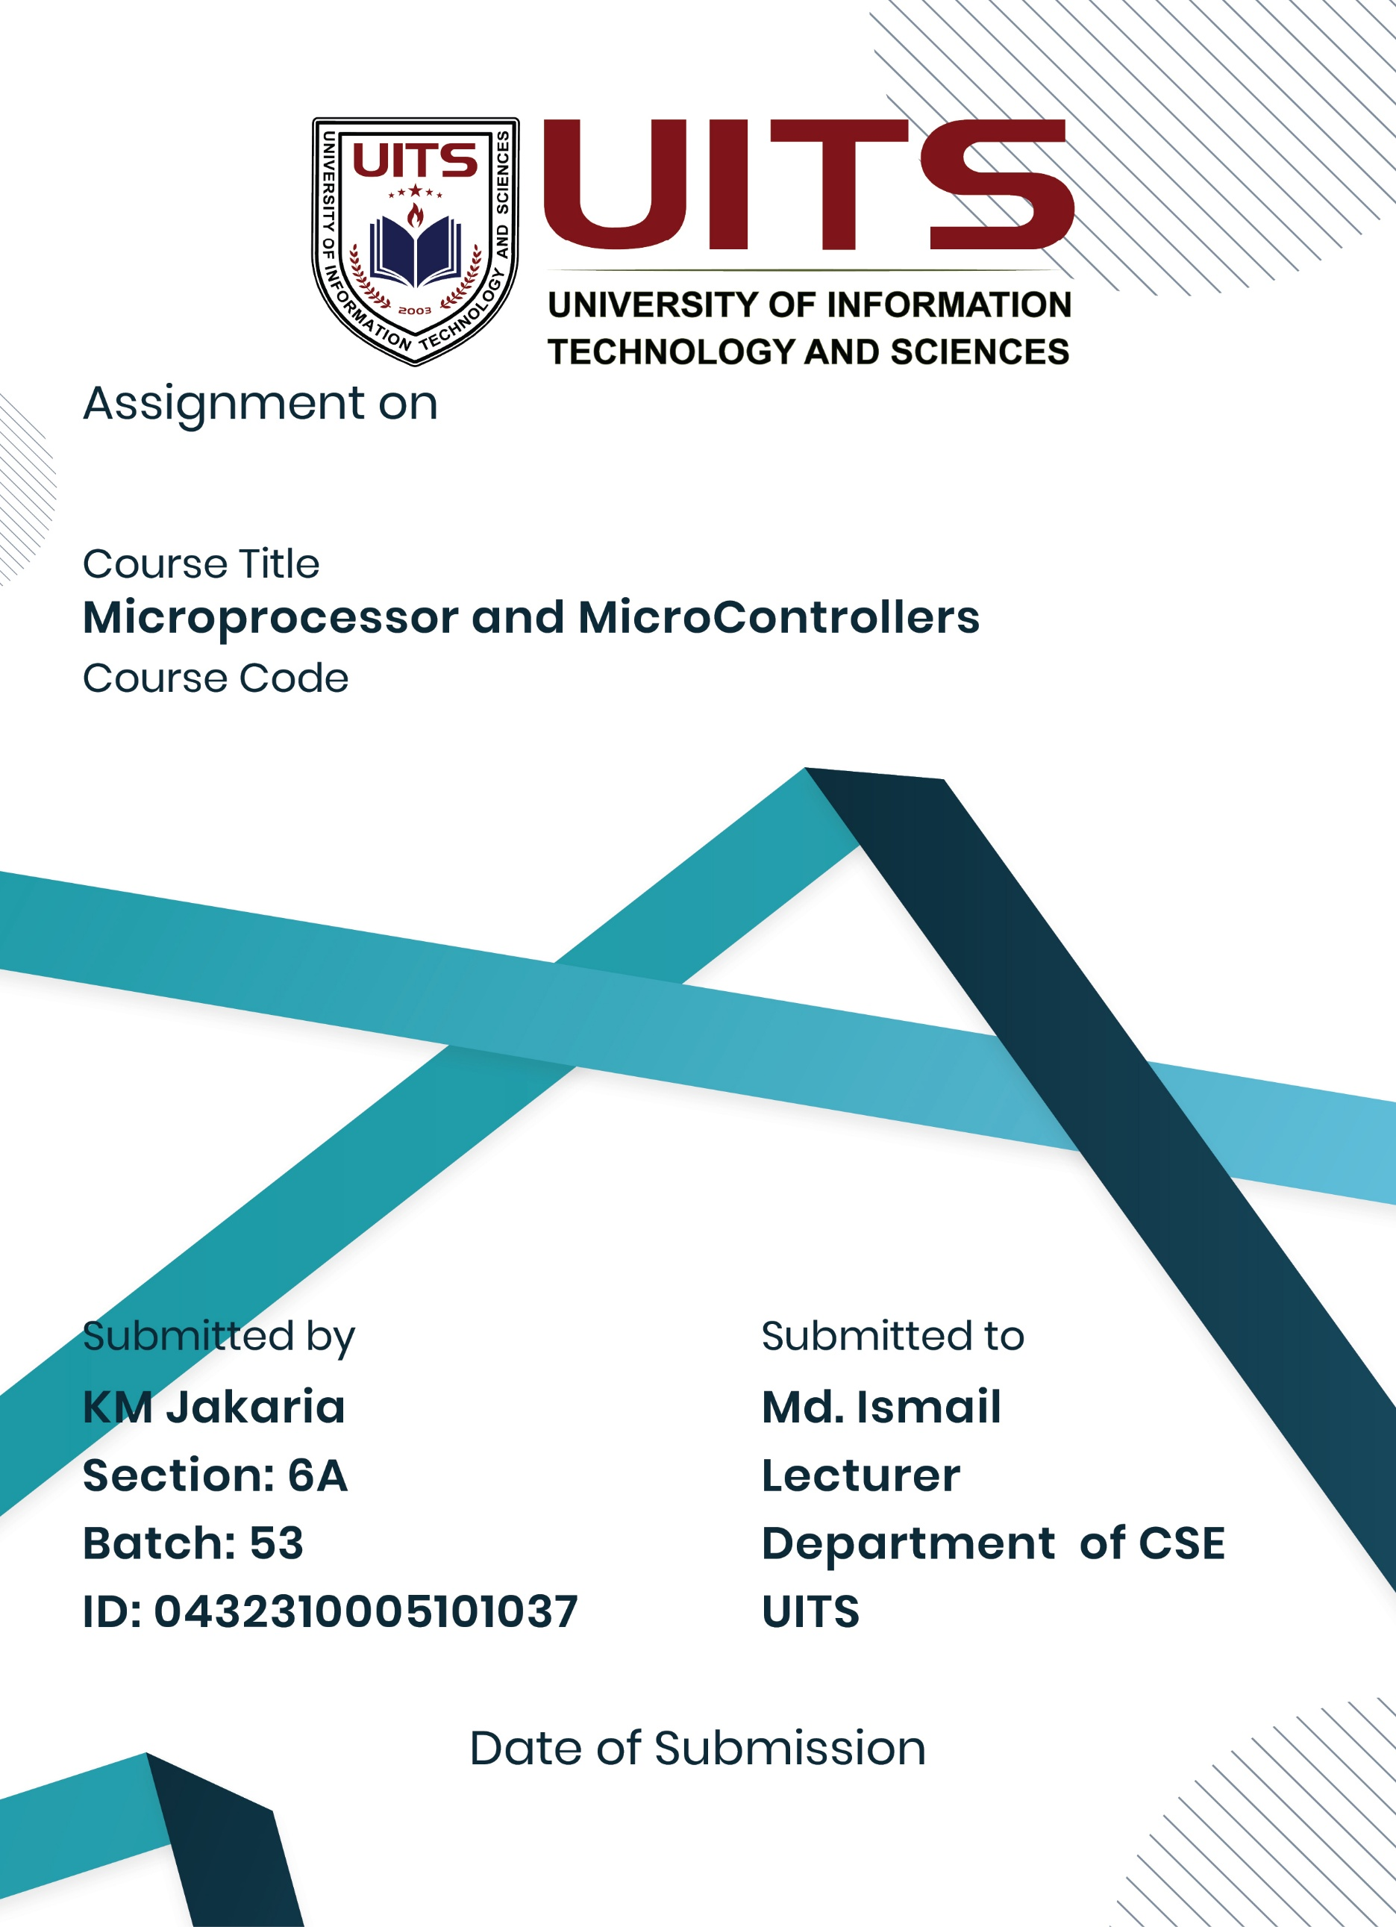
Lab Report -07
10 Nov, 2025
CSE 360
Problem No: 01
Experiment No: 07
Experiment Name: Check Whether a String Is Palindrome or Not Using Assembly Language
Process:
A palindrome is a sequence of characters that reads the same forward and backward. In this program, the entered string is compared character by character from both ends toward the center. If all character’s match, the string is a palindrome; otherwise, it is not.
Algorithm:
1. Start the program.
2. Initialize the data segment.
3. Take the input string from the user.
4. Store the string in memory.
5. Determine the length of the string.
6. Compare characters from the beginning and end:
o If all corresponding characters match, continue.
o If any mismatch occurs, set a flag to indicate "not palindrome".
7. Display the appropriate message:
o “String is a palindrome.”
o “String is not a palindrome.”
8. Stop the program.

Implementation:
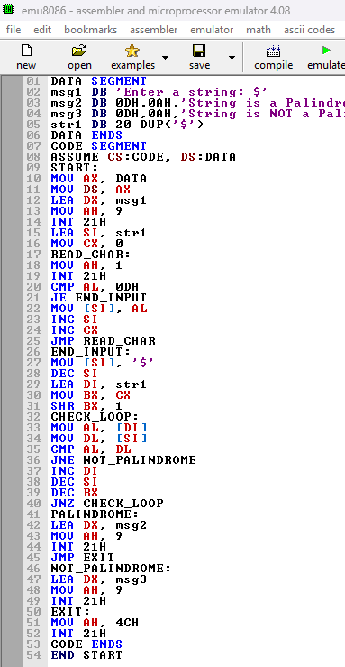
Result:
The application displays every character array element on the screen. Every string in the string array is printed on a separate line by the application.
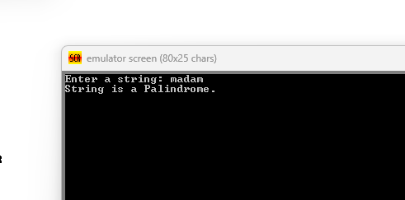

Conclusion:
The assembly language program to reverse a string was successfully implemented and executed. The program demonstrated pointer manipulation and character find out as palindrome in 8086 assembly.

